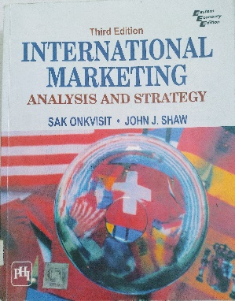

Module 1
- Discuss the process of international marketing. Pg 7
- Explain the benefits associated with international marketing. Pg 22
- Elaborate on the process of internationalization. Pg 21
- Explain the theory of absolute advantage. Pg 39
- Explain the theory of relative advantage. Pg 40.
- Discuss the tariff related marketing barriers. Pg 90
- Discuss the non-tariff related marketing barriers. Pg 95

Module 2
- Elaborate the six types of political systems. Pg 135
- Discuss the three types of economic systems. Pg 137
- Differentiate between common law and statute law. Pg 169
- Discuss trademark, copyright, patent and trade secret in brief. Pg 182
- Define culture and discuss its characteristics. Pg 205

Module 3:
- Differentiate between psychology, sociology and cultural anthropology. Pg 251
- Explain any three methods of data collection. Pg 298
- Differentiate between reliability and validity. Pg 303
- Elaborate the six types of market entry strategies. Pg 328
- Discuss the any four variables studied for doing market analysis of a country. Pg 323
- Write a short note on Free Trade Zones. Pg 357

Module 4:
- Discuss the steps in new product development. Pg 378
- Market segmentation is necessary. Justify. Pg 380
- Elaborate the six factors that have a bearing on the product adoption process. Pg 384
- Explain the four levels of branding decisions. Pg 427
- Elaborate on the desired characteristics of a brand. Pg 443
- Discuss any four advertising media useful for international marketing. Pg 569

Module 5:
- Discuss any four factors that help explain the pricing behaviour of an international firm. Pg 608
- Explain the four types of dumping. Pg 617
- Elaborate the concept of transfer pricing. Pg 628
- Define countertrade and discuss its types. Pg 636
- Explain any four types of letter of credit. Pg 651
- Discuss the four types of offshore financial centers. Pg 688

