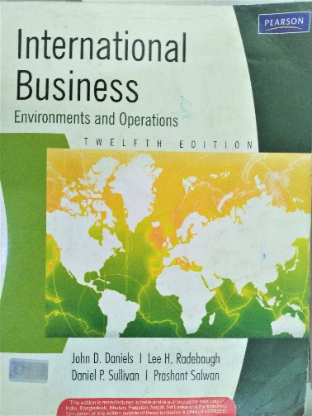

Question Bank

Module 1
- Define globalization. What are the forces that drive globalization? Pg 8
- Discuss the problems associated (challenges) with globalization. Pg 14
- Why do companies engage in international business? Pg 18
- Elaborate on the three modes of international operations. Pg 19
- Discuss the physical and social factors affecting international business operations. Pg 23
- Elaborate on the competitive environment facing international business. Pg 25

Module 2
- Discuss PESTEL analysis with examples.
- Differentiate between polycentrism and ethnocentrism and geocentrism. Pg 79
- Explain any three strategies for instituting change. Pg 83
- Discuss the five different types of democracy. Pg 103
- Explain the four types of political risk. Pg 112
- Discuss the strategic concerns arising out of the legal system of a particular country. Pg 124
- Elaborate any four features of an economy. Pg 154
- Compare and contrast the theory of absolute advantage and comparative advantage. Pg 227

Module 3
- Explain any three ECONOMIC rationales for government intervention in international business. Pg 269
- Explain any three NON-ECONOMIC rationales for government intervention in international business. Pg 277
- Explain the tariff barriers for international business. Pg 280
- Explain the non -tariff barriers for international business. Pg 281
- Elaborate the role of WTO in international business. Pg 298
- What is regional economic integration? What are the effects of such integrations? Pg 301

Module 4
- Discuss the advantages and disadvantages of exporting. Pg 504 / 508
- Discuss the three stages of export development. Pg 507
- Elaborate on the three types of importers. Pg 513
- Explain the three methods of direct selling. Pg 521
- Explain any six out of seven documents important for exporters. Pg 525
- Elaborate on the concept of countertrade. Pg 529

