Name of Institute: INDUS INSTITUTE OF MANAGEMENT
Name of Faculty: Prof. PARSHVA SHAH

Course code: IMB0504
Course name: Introduction to Taxation
Pre-requisites:
Credit points: 3
Offered Semester: V

Course Coordinator (weeks 15)
Full Name: Prof. Parshva Jitendrakumar Shah
Department with siting location: MBA Department, Bhawar Buliding 4th Floor
Telephone: 9737530515
Email: parshvashah.mba@indusuni.ac.in
Consultation times: 2.00 PM to 4.00 PM

Course Lecturer (weeks 15)
Full Name: Prof. Parshva Jitendrakumar Shah
Department with siting location: MBA Department, Bhawar Buliding 4th Floor
Telephone: 9737530515
Email: parshvashah.mba@indusuni.ac.in
Consultation times: 2.00 PM to 4.00 PM

Students will be contacted throughout the Session via Mail with important information relating to this Course.

Course Objectives

The aim of the course is to make students aware about various provisions of direct tax laws and details regarding five heads of income and its practical implications. Taxation being a major policy decision in the economic scenario, it requires in-depth understanding of its effect on individuals and organizations.

Course Outcomes (CO)
CO1- To collect the basic concepts and definitions of Income Tax Act 1961 & To know the
residential status of assessee
CO2- To familiar with the computation of income from business and profession
CO3- To familiar with the computation of income from Capital gain
CO4- To know the difference between tax evasion and tax planning & able to know
different types of incomes and their taxability and expenses and their deductibility.
CO5- To know the impact of tax laws on companies and individuals
CO6- Be familiar with different strategies to minimize the tax liability

Course Outline

Unit-I
• Introduction of Direct taxes
• Residential status

Unit-II
• Income under the head ‘House Property’

Unit-III
• Income under the head ‘Business & Profession’

Unit-IV
• Income under the head ‘Capital claims
• Income under the head ‘Other sources’

Unit-V
• Income under the head ‘Salaries’

Method of delivery
Face to face lectures, self study material, Active Learning Techniques,Chalk & Board, Transparencies & OHP, Power Point Presentation(PPT), Hand Outs, Visits, Seminar, Group Discussion, Report writing, Using Mini, Minor, Major Projects, etc.

Study time
3 lecture per week, Average attendance 80%

CO-PO Mapping (PO: Program Outcomes)
 | Introduction to Taxation | PO1 | PO2 | PO3 | PO4 | PO5
CO1 | To collect the basic concepts and definitions of Income Tax Act 1961 &amp; To know the residential status  Of assessee. | 2 | 3 | 2 | 3 | 3
CO2 | To familiar with the computation of income from business and profession | 2 | 2 | 2 | 2 | 3
CO3 | To familiar with the computation of income from Capital gain | 2 | 2 | 3 | 3 | 2
CO4 | To know the difference between tax evasion and tax planning & able to know different types of incomes and their taxability and expenses and their deductibility. | 2 | 2 | 2 | 3 | 3
CO5 | To know the impact of tax laws on companies and individuals | 2 | 2 | 3 | 2 | 3
CO6 | Be familiar with different strategies to minimize the tax liability | 3 | 2 | 3 | 2 | 2

Blooms Taxonomy and Knowledge retention (For reference)
(Blooms taxonomy has been given for reference)

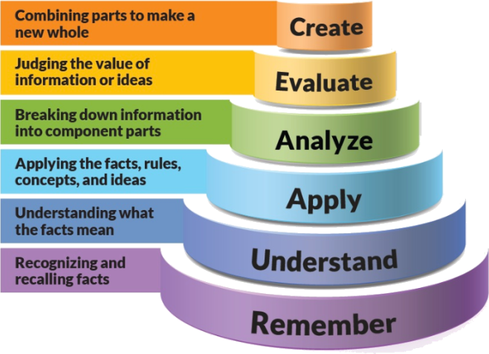
Figure 1: Blooms Taxonomy

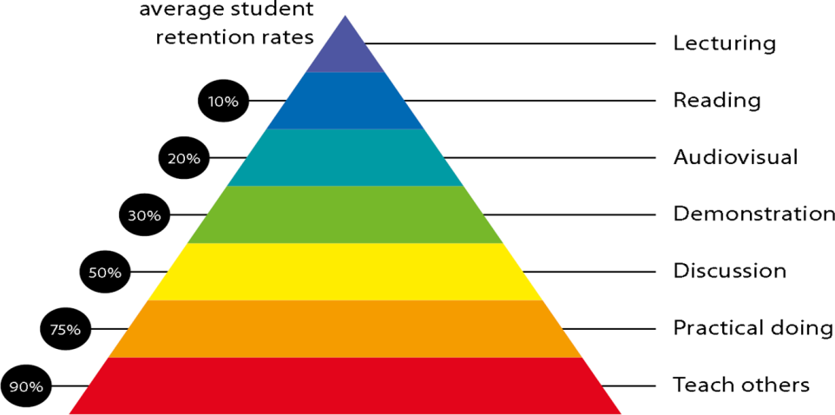
Figure 2: Knowledge retention

Graduate Qualities and Capabilities covered
(Qualities graduates harness crediting this Course)

General Graduate Qualities | Specific Department of ______Graduate Capabilities
Informed  Disciplinary Knowledge  - Basics of Income Tax  - Five Heads of Income  - Computation of Tax  - How individual can file their return of income and get deduction accordingly. | 1 Professional knowledge, grounding & awareness
Independent learners  - Metacognition  - Planning  - Evaluating | 2 Information literacy, gathering & processing
Problem solvers  Thinking • critical • creative • practical | 4 Problem solving skills
Effective communicators  Relating • communication • team skills • influencing • acting ethically • cross-cultural awareness | 5 Written communication
 | 6 Oral communication
 | 7 Teamwork
Responsible  Learning • capacity for life-long learning • flexibility • adaptability | 10 Sustainability, societal & environmental impact

Practical work:
Case Study, Presentation , Practical problems of each .
- ASSIGNMENT -1 Theory aspect question
- ASSIGNMENT -2 Practical questions
- MCQ Test
- Practical Case Discussion
- Projects

Lecture/tutorial times
As per time table

Attendance Requirements

The University norms states that it is the responsibility of students to attend all lectures, tutorials, seminars and practical work as stipulated in the Course outline. Minimum attendance requirement as per university norms is compulsory for being eligible for mid and end semester examinations.

Details of referencing system to be used in written work

Text books

- Systematic approach to Income tax by Dr.Girish Ahuja & Dr. Ravi Gupta; Publisher – Bharat prakashan
- Systematic approach to Direct taxes by Dy Dr. Vinod Singhania; Publisher – Taxmann

Additional Materials
Names of newspapers, magazines to be referred for better understanding of the course:
- Times of India, Economics Times, Business Standard ,
- Taxman. Taxman Allied Services Pvt. Ltd., New Delhi.
- Current Tax Reporter. Current Tax Reporter, Jodhpur.

ASSESSMENT GUIDELINES
Your final course mark will be calculated from the following:
- ASSIGNMENT -1 Theory aspect question 05 Marks
- ASSIGNMENT -2 Practical questions 10 Marks
- Mid Semester 40 Marks
- Class Performance / Attendance 05 Marks
- End Semester 40 Marks

SUPPLEMENTARY ASSESSMENT

Students who receive an overall mark less than 40% in mid semester or end semester will be considered for supplementary assessment in the respective components (i.e mid semester or end semester) of semester concerned. Students must make themselves available during the supplementary examination period to take up the respective components (mid semester or end semester) and need to obtain the required minimum 40% marks to clear the concerned components.

Late Work
Late assignments will not be accepted without supporting documentation. Late submission of the reports will result in a deduction of -% of the maximum mark per calendar day

Format
All assignments must be presented in a neat, legible format with all information sources correctly referenced. Assignment material handed in throughout the session that is not neat and legible will not be marked and will be returned to the student.

Retention of Written Work
Written assessment work will be retained by the Course coordinator/lecturer for two weeks after marking to be collected by the students.

University and Faculty Policies
Students should make themselves aware of the University and/or Faculty Policies regarding plagiarism, special consideration, supplementary examinations and other educational issues and student matters.

Plagiarism - Plagiarism is not acceptable and may result in the imposition of severe penalties. Plagiarism is the use of another person’s work, or idea, as if it is his or her own - if you have any doubts at all on what constitutes plagiarism, please consult your Course coordinator or lecturer. Plagiarism will be penalized severely.

Do not copy the work of other students.
Do not share your work with other students (except where required for a group activity or assessment)

Course schedule (subject to change)
(Mention quiz, assignment submission, breaks etc as well in the table under the Teaching Learning Activity Column)

 | Week # | Topic & contents |  |  | CO Addressed |  |  | Teaching Learning Activity (TLA)
 | Weeks 1 | Introduction to Income-tax, Basic Definitions of Income-tax |  |  | CO1,CO2,CO3,CO4,CO5,CO6 | Chalk & Board / / PPT / Handouts / Tutorials / Assignments,
 | Weeks 2 | Determination of Residential Status – Individual, HUF, Firm & Company |  |  | CO1,CO2,CO4,CO5,CO6 | Chalk & Board / / PPT / Handouts / Tutorials / Assignments,
 | Week 3 | Incidence of Tax & Income Exempt from Tax |  |  | CO1,CO4,CO5,CO6 | Chalk & Board / / PPT / Handouts / Tutorials / Assignments,
 | Week 4 | Basic Understanding – Five Heads of Income and Tax Computation for Individual (Slab System) & Company. |  |  | CO1 ,CO4,CO5,CO6 | Chalk & Board / / PPT / Handouts / Tutorials / Assignments,
 | Week 5 | Income under the head “ Salary “ and Employee Remuneration Planning |  |  | CO1 ,CO4,CO5,CO6 | Chalk & Board / / PPT / Handouts / Tutorials / Assignments,
 | Week 6 | Income under the head “ Salary “ and Employee Remuneration Planning |  | CO1,CO4,CO5,CO6 |  |  | Chalk & Board / / PPT / Handouts / Tutorials / Assignments,
 | Week 7 | Income under the head “ Profits and gains of business or profession” – Specific Deduction & Specific Disallowances |  | CO1,CO2,CO4,CO5,CO6 |  |  | Chalk & Board / / PPT / Handouts / Tutorials / Assignments,
 | Week 8 | Income under the head “ Profits and gains of business or profession” – Specific Deduction & Specific Disallowances |  | CO1,CO2,CO4,CO5,CO6 |  |  | Chalk & Board / / PPT / Handouts / Tutorials / Assignments,
 | Week 9 | Income under the head “ Capital Gains” |  | CO1,CO3,CO4,CO5,CO6 |  |  | Chalk & Board / / PPT / Handouts / Tutorials / Assignments,
 | Week 10 | Income under the head “ Capital Gains” |  | CO1,CO3,CO4,CO5,CO6 |  |  | Chalk & Board / / PPT / Handouts / Tutorials / Assignments,
 | Week 11 | Mid Term Exam |  | Mid Term Exam |  |  | Mid Term Exam
 | Week 12 | Practical Implication of above heads of income |  | CO1,CO2,CO3,CO4,CO5,CO6 |  |  | Chalk & Board / / PPT / Handouts / Tutorials / Assignments,
 | Week 13 | Income under the head “ House Property” |  | CO1,CO4,CO5,CO6 |  |  | Chalk & Board / / PPT / Handouts / Tutorials / Assignments,
 | Week 14 | Income under the head “ House Property” |  | CO1,CO4,CO5,CO6 |  |  | Chalk & Board / / PPT / Handouts / Tutorials / Assignments,
 | Week 15 | Income under the head “ Income from Other Sources” |  | CO4,CO5,CO6 |  |  | Chalk & Board / / PPT / Handouts / Tutorials / Assignments,

Assessment Process:

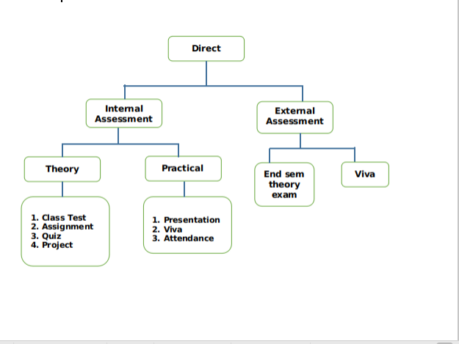
Direct Assessment method – The knowledge and skills learnt by the students are assessed directly from their performance through internal assessment and external assessment processes.
External assessment- Performance of student is recorded in university theory exams, laboratory exams and project evaluation.
Internal assessment- Performance of student is recorded through class assignments and tutorials, internal assessment tests, laboratory assignments, seminars and project progress review and evaluation.
TAttainment of Course Outcomes (CO’s)Test

For End Semester Theory and Practical Exams
- Attainment Level 1: If < 45% students scoring ≥60% marks
- Attainment Level 2: If >45-75% students scoring ≥60% marks
- Attainment Level 3: If >75-100% students scoring ≥60% marks
For Internal Theory and Practical Exams
- Attainment Level 1: If <45% students scoring ≥75% marks
- Attainment Level 2: If >45-75% students scoring ≥75% marks
- Attainment Level 3: If >75-100% students scoring ≥75% marks
Weights of Attainments are assigned as per University Evaluation criteria as below for A.Y. 2019-20
1. For all courses except courses marked with (*)
INDUS University End Sem Examinations : Weightage: 40%
Internal Assessment : Weightage: 60%
2. Courses marked with (*)
INDUS University External Examinations : Weightage: 0%
Internal Assessment : Weightage: 100%

Internal Component with COs mapping
 | Name of the Component | Total marks | CO mapped
Component-1 | Mid Sem | 40 | CO-1, CO-2,CO-3
Component-2 | Assignment-1 | 05 | CO--1, CO-2,
Component-3 | Assignment-1I | 10 | CO-3, CO-4, CO-5, CO-6
Component-4 | Attendance | 05 | CO--1,CO-2,CO-3, CO-4, CO-5, CO-6

Course Attainment

Academic Year 2019-2020

Course Name with Code | Introduction to Taxation (BB0503)
Class | 3rd Semester, BBA
Faculty Name | Mr. Parshva Shah

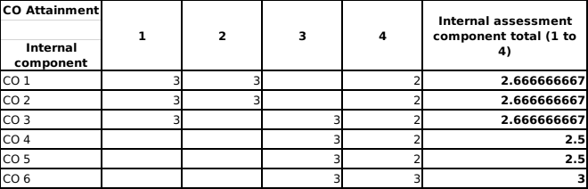

CO Attainment

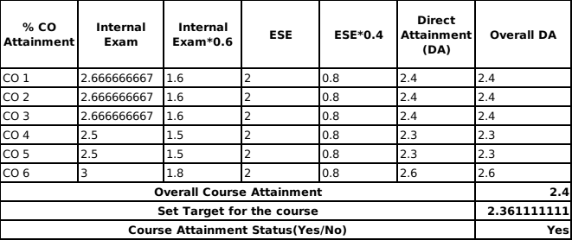

Best Performing CO: | CO1, CO3
Least Performing CO | CO4,CO5

Observations:
1 | Overall attainment level of CO4 and CO5 is less
2 | CO attainment has been attained

Plan of Action:
1 | More focus is need to be provided for CO4 and CO5
2 | More contribution from the faculty is required for CO4 and CO5

