Accounting Problems on Insolvency Accounts

Insolvency Accounts: Problem and Solution # 1.
Mr. P of Mumbai, finding himself unable to meet his creditors, has to prepare a Statement of Affairs for which the following particulars are available:
Leasehold Property, Rs 1,00,000 estimated to realise, Rs 90,000.
Plant and Machinery Rs 40,000 estimated to realise, Rs 30,000.
Stock in Trade, Rs 20,000 estimated to realise, Rs 14,000.
Book Debts, Good Rs 60,000; Doubtful Rs 5,000 estimated to realize 50%; Bad, Rs 14,000. :
Bills in hand, Rs 3,750.
Life Policy for Rs 25,000 whose surrender value is Rs 5,000 held by the insurance company against a loan of Rs 2,000.
Household Furniture, Rs 3,600; Household Debts, Rs 2,900.
Bills Discounted, Rs 6,000; Rs 2,000 likely to be dishonoured.
Loan on mortgage of Leasehold Rs 50,000; Cash in hand, Rs 100.
Bank Overdraft secured by personal guarantee of P’s brother and second mortgage on Leasehold, Rs 50,000.
Unsecured Creditors, Rs 1,50,000. Loan from N, Rs 2,500 secured by a second charge on life policy. Ground Rent on Leasehold for three months accrued; Rs 250.
He could not pay his office clerks’ (two in number) salaries for six months, Rs 1,500 and also rates and taxes amounting to Rs 1,500.
Prepare the Statement of Affairs.
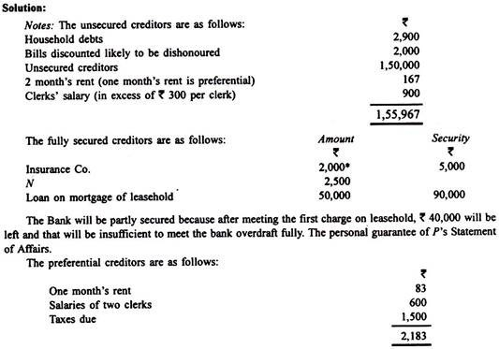

The following is the Statement of Affairs in proper form:
Statement of Affairs:
(As required by the Presidency-Towns Insolvency Act, 1909) In the High Court of Judicature at…
In Insolvency:
To the Insolvent,—You are required to fill up, carefully and accurately, this sheet and the several sheets, A, B, C, E, F, G and H, showing the state of your affairs on the day on which the order of adjudication was made against, you, viz., the ….. day of…. 20 ….
Such sheet, when filled up, will constitute your schedule and must be verified by Oath or Declaration.
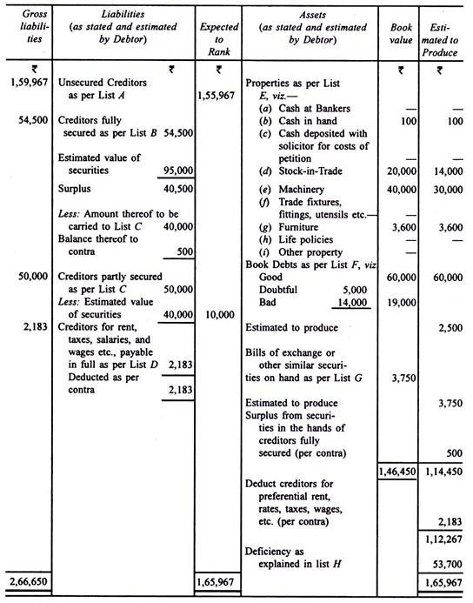

Insolvency Accounts: Problem and Solution # 2.
A filed his petition on 31st March, 2012, and his statement of affairs was composed of the following figures:
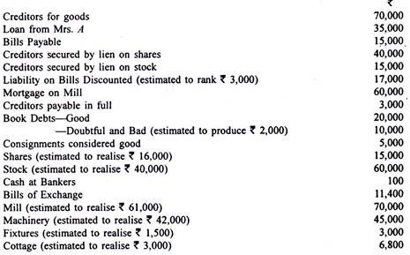
On 1st April six years ago, he had a capital of Rs 50,000. Profits were made totaling Rs 45 500 in the first four years and losses were incurred totaling Rs 25,000 in the last two years after allowing Rs 2,500 per year interest on capital. Withdrawals amounted to Rs 77, 200. Prepare Statement of Affairs and Deficiency Account.
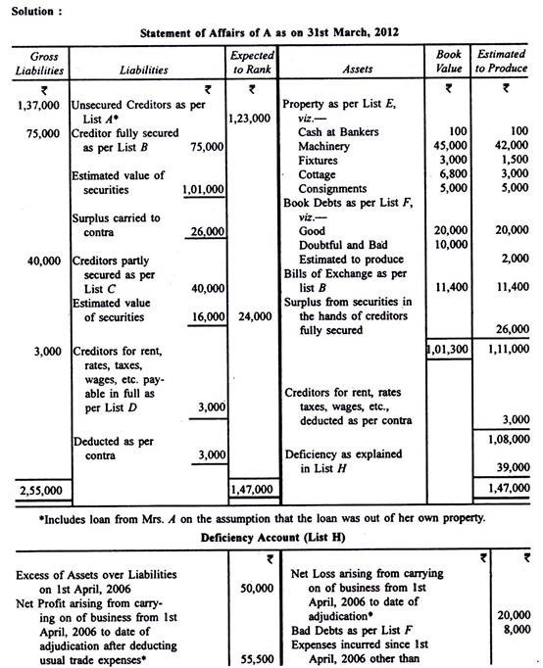
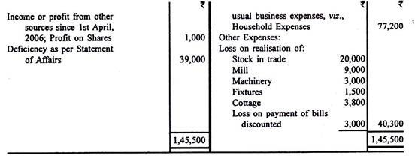

Insolvency Accounts: Problem and Solution # 3.
Mohan of Agra commenced business on 1st April, 2007 with capital of Rs 3,30,000. He drew on the average Rs 30,000 per year. His profits for 3 years were Rs 70,000; he did not prepare proper accounts for the next two years. On 31st March, 2012 an adjudication order was made against him. He submits the following information from which his Statement of Affairs and Deficiency Account are to be prepared:
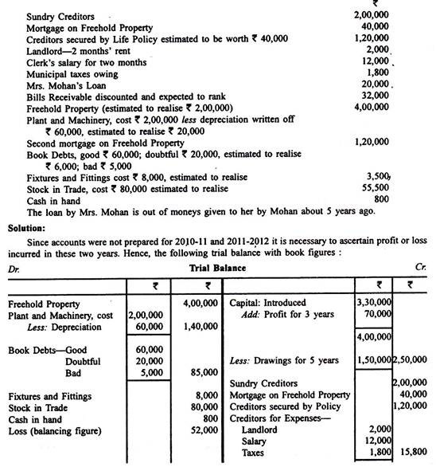
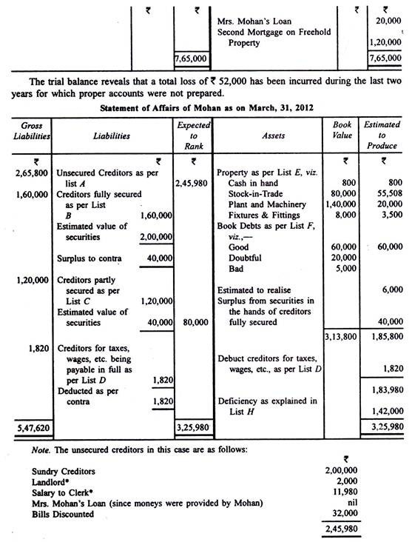
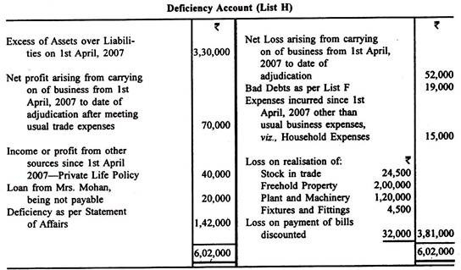

Insolvency Accounts: Problem and Solution # 4.
On 31st March, 2012 P filed his petition to be declared insolvent. His balance sheet on that date stood as follows:
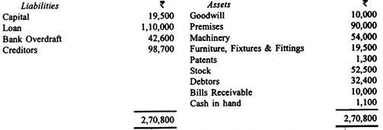
In addition to the above mentioned bills receivable of Rs 10,000 P hand another bill receivable for Rs 5,000 due on 6th May, 2012 which he had got discounted with the bank on 7th March, 2012 for Rs 4,700. Goodwill and patents were worthless.
Other assets were estimated to produce as follows:
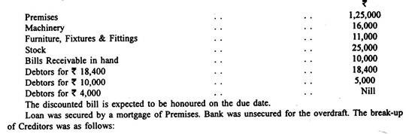
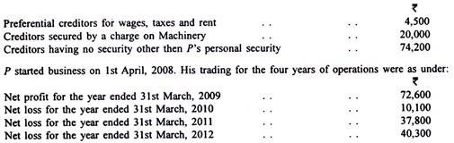
Besides the abovementioned trading losses, P lost Rs 1,000 in a bet in December, 2010.
For the first two years ended 31st March, 2010 his household expenses, for which he withdraw money from the business, averaged Rs 3,500 per month. After suffering losses in the year ended 31st March, 2010 he reduced his domestic expenses and hence in the next two years, his private expenses averaged Rs 3,000 per month only.
On the basis of the abovementioned information, prepare P’s Statement of Affairs and Deficiency Account.
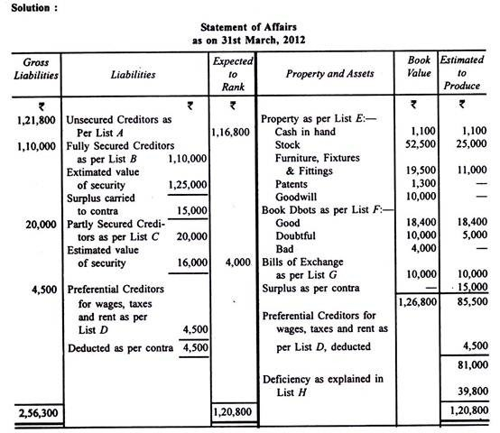
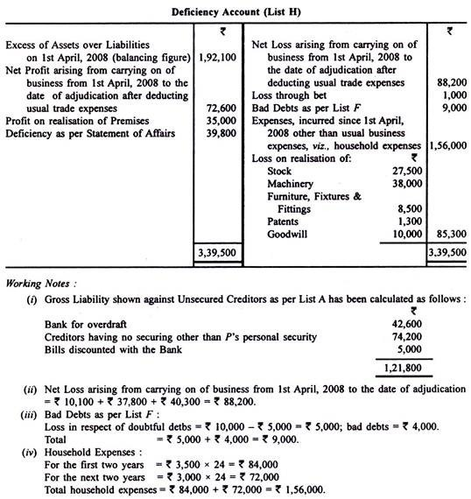

Insolvency Accounts: Problem and Solution # 5.
On 31st March, 2012 the Balance Sheet of A and B of Kolkata was as follows:
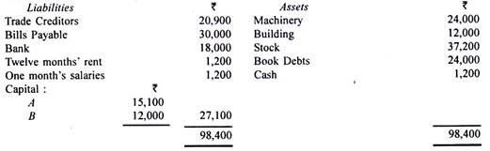
A owed personally Rs 10,000 and he had in addition to the interest in the firm, a house which cost Rs 6,000, furniture Rs 2,400 and life policies on which he had paid premiums amounting to Rs 1,200. B owed Rs 1,880 privately. He had furniture costing Rs 1,200 and a life policy on which Rs 3,600 had been paid as premium. The Bank held deeds of A’s property and his life policies. It became necessary to call the creditors together.
The partnership assets were valued as follows:
Machinery, Rs 13,080; Buildings, Rs 6,000; Book Debts, Good, Rs 12,000, Doubtful, Rs 6,000 (estimated to realise 60%) and Bad, Rs 6,000; Stock, Rs 20,000.
The firm had in its premises goods belonging to another firm and which were lying for a fairly long time. The book value of such goods was Rs 7,000; the Official Receiver estimated those at Rs 4,000.
A’s property was considered to be worth Rs 6,000, his life policies, Rs 600 and his furniture, Rs 1,800. B’s life policies were worth Rs 1,800 and his furniture, Rs 600.
Prepare the various Statement of Affairs and Deficiency Accounts.
Solution:
A point to note is that whereas A’s private estate is not sufficient to pay A’s private liabilities, there is a surplus in B’s estate. It totals Rs 2,400, and he owes personally Rs 1,880 leaving a surplus of Rs 520 which will be used for paying firm’s creditors.
