Name of Institute: Institute of Management Studies (IMS)

Name of Faculty: Dr Daisy Kurien

Course code: IMBO712
Course name: Product and Brand Management
Pre-requisites: Marketing Specialisation
Credit points: 3 Credits
Offered Semester: II

Course Lecturer (weeks 01 – 15)
Full Name: Dr Daisy Kurien
Department with siting location: Management
Telephone:9428412928
Email: daisykurien.mba@indusuni.ac.in
Consultation times:2:00 pm to 4:00 pm

Students will be contacted throughout the Session via Mail with important information relating to this Course.

Course Objectives
By participating in and understanding all facets of this Course a student will be able:

• To develop an understanding of the basic branding principles and their exposure to classic and contemporary branding applications.
• To make the students aware about the role of brands, the concept of brand equity, and the advantages of creating strong brands.
• To increase the understanding of the important issues in planning, implementing, and evaluating brand strategies.
• To acquaint the students with the appropriate concepts, theories, models and other tools to make better brand decisions.
• To understand the latest developments and cultivate an understanding of the adjustments to be made in branding strategies over time and geographic boundaries to maximize brand equity.

Course Outcomes (CO)

At the completion of the course, the student will be able to:
CO1: Student shall be able to learn understand the strategic role of product management in organizational.
CO2: Understanding of functional context and the financial and other merits and the
knowledge about various facets of the job of a product manager.
CO3: Student shall be able to learn &amp; Understand the different approaches to measure brand equity.
CO4: To understand the conceptual framework for managing brands and roles of brand.
CO5: To understand the concept of brand equity and the advantages of create strong brand.
CO6: Practically develop a brand, including positioning and communication

Course Outline
Module 1 –
Introduction to Product Management, Concepts of Product, Classification of products, Product Decisions, Product Differentiation, New Product Development Process, Need for new products
Module 2 –
The Diffusion process, The Adoption process, Rates of adoption on Innovations Product Life Cycle, Managing a Product during various stages of PLC, Product Strategies. New challenges for marketers in India
Module 3 –
Branding & Brand Management, The concepts of Brand Equity, Creating brands in a competitive market. Brand Positioning and Brand Associations. Using Brand Elements to create brand equity
Module 4 –
Designing Marketing Programmes to Build Brand Equity. Leveraging Secondary Brand Associations. Measuring Sources of Brand Equity and Brand Equity measurement approaches.
Module 5 –
Growing and Sustaining Brand Equity: Designing and Implementing Branding Strategies, Launching Brand Extensions Products, Managing brands overtime and geographic boundaries, revitalization of brands.

Method of delivery
Lectures, Role plays, Case studies, Video Cases

Study time

Three hours per week

CO-PO Mapping (PO: Program Outcomes)

 | PO 1 | PO 2 | PO 3 | PO 4 | PO 5 | PO 6
CO 1 | 2 | 3 | 2 | 3 | 2 | 3
CO 2 | 3 | 1 | 1 | 3 | 3 | 1
CO 3 | 1 | 3 | 2 | 3 | 3 | 3
CO 4 | 1 | 3 | 3 | 1 | 3 | 3
CO 5 | 2 | 3 | 3 | 1 | 2 | 3
CO 6 | 1 | 3 | 3 | 1 | 3 | 1

Blooms Taxonomyand Knowledge retention(For reference)
(Blooms taxonomy has been given for reference)

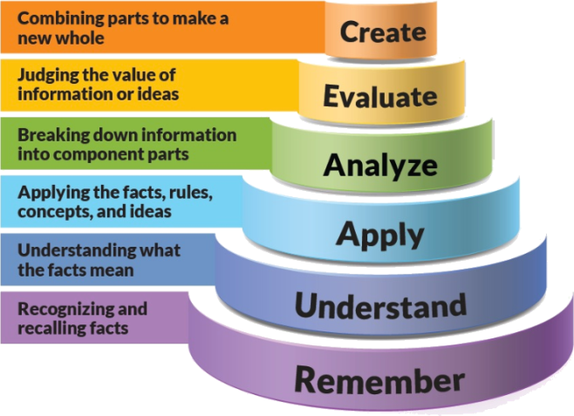
Figure 1: Blooms Taxonomy
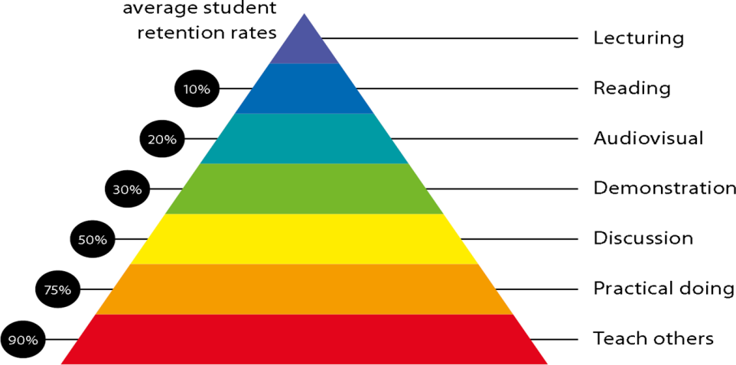
Figure 2: Knowledge retention

Graduate Qualities and Capabilities covered
(Qualities graduates harness crediting this Course)

General Graduate Qualities | Specific Department of ManagementGraduate Capabilities
Informed  Gain an understanding of marketing issues dominating the market in present time which may pose as a threat in marketing but is handled well may lead to better marketer- customer relation. | 1 Market knowledge, & awareness
Independent learners  Locate, evaluate and synthesize complex situations and offer perspectives. Opportunities to acquire these abilities are developed through lectures, and case discussion. | 2 Information literacy, gathering & processing
Problem solvers  Developing critical thinking skills that are pertinent for problem solving and innovation in today’s competitive market. Critically analyze the situation and offer solutions to situations. | 4 Problem solving skills
Effective communicators  Develop the ability to reflect on issues on hand. Through active participation enhance the skills to communicate verbally and in writing and develop practices expected of today’s professionals. | 5 Written communication
 | 6 Oral communication
 | 7 Teamwork
Responsible  Gain a better understanding of sustainable market. Being responsible in dealing and delivering value to all stakeholders | 10 Sustainability, societal & environmental impact

Practical work:
Live project/ Assignments

Lecture/tutorial times:
Lecture Monday 9:55 - 10:50 am Room LH 35
Lecture Wednesday 2:15 - 03:10 am Room LH 35
Lecture Friday 9:55 - 10:50 am. Room LH 35

Attendance Requirements

The University norms states that it is the responsibility of students to attend all lectures, tutorials, seminars and practical work as stipulated in the Course outline. Minimum attendance requirement as per university norms is compulsory for being eligible for mid and end semester examinations.

Details of referencing system to be used in written work

Text books

- Lehman and Winer, Product Management, Tata McGraw Hill
- Kevin Lane Keller, M.G. Rameswaram, Isaac Jacob ; third edition -Strategic Brand Management, Pearson Education
- Kirti Dutta, Brand Management- Principles and Practices; first edition Oxford University Press

Reference Books:
- Ramanuj Majumdar, Product Management in India, PHI EEE, Latest Edition
- Harish V Verma,Brand Management, 2/e, Excel Books
- Chunnawalla,Compendium Brand Management, HPH, 1/e, 2003
- S Ramesh Kumar, Managing Indian Brands,Vikas
- Richard Elliott & Larry Perclu,Strategic Brand Management,Oxford Press, 1/e
- Chernatony, Creating powerful brands, Elsevier Publication, 1/e

Additional Materials
- Newspaper articles
- Video cases on current business issues

ASSESSMENT GUIDELINES
Your final course mark will be calculated from the following:
Assignment 1 5%
Assignment 2 5%
Presentation 5%
Attendance 5 %
Mid semester 40%
Final exam (closed book) 40%

SUPPLEMENTARY ASSESSMENT
Students who receive an overall mark less than 40% in mid semester or end semester will be considered for supplementary assessment in the respective components (i.e mid semester or end semester) of semester concerned. Students must make themselves available during the supplementary examination period to take up the respective components (mid semester or end semester) and need to obtain the required minimum 60% marks to clear the concerned components.

Practical Work Report/Laboratory Report:
A report on the practical work is due the subsequent week after completion of the class by each group.

Late Work
Late assignments will not be accepted without supporting documentation. Late submission of the reports will result in a deduction of 5% of the maximum mark per calendar day

Format
All assignments must be presented in a neat, legible format with all information sources correctly referenced. Assignment material handed in throughout the session that is not neat and legible will not be marked and will be returned to the student.

Retention of Written Work
Written assessment work will be retained by the Course coordinator/lecturer for two weeks after marking to be collected by the students.

University and Faculty Policies
Students should make themselves aware of the University and/or Faculty Policies regarding plagiarism, special consideration, supplementary examinations and other educational issues and student matters.

Plagiarism - Plagiarism is not acceptable and may result in the imposition of severe penalties. Plagiarism is the use of another person’s work, or idea, as if it is his or her own - if you have any doubts at all on what constitutes plagiarism, please consult your Course coordinator or lecturer. Plagiarism will be penalized severely.

Do not copy the work of other students.
Do not share your work with other students (except where required for a group activity or assessment)
.

Courseschedule(subject to change)

 | Week # | Topic & contents | CO Addressed | Teaching Learning Activity (TLA)
 | Weeks 1 | Introduction to Product Management, Concepts of Product, | CO1 &CO2 | Lecture, Video, & Case Discussion
 | Weeks 2 | Classification of products, Product Decisions, Product Differentiation, | CO1 & CO2 | Lecture, Video, & Case Discussion
 | Week 3 | New Product Development Process, Need for new products | CO1, CO2 | Lecture, Video, & Case Discussion
 | Week 4 | The Diffusion process, The Adoption process, | CO1, CO2 | Lecture, Video, & Case Discussion
 | Week 5 | Rates of adoption on Innovations Product Life Cycle, Managing a Product during various stages of PLC, | CO1, CO2 | Lecture, Video, & Case Discussion
 | Week 6 | Product Strategies. New challenges for marketers in India | CO1, CO2, CO3 | Lecture, Video, & Case Discussion
 | Week 7 | Branding & Brand Management, The concepts of Brand Equity, | CO3 | Lecture, Video, & Case Discussion
 | Week 8 | Creating brands in a competitive market. Brand Positioning and Brand Associations. | CO3, CO4 | Lecture, Video, & Case Discussion
 | Week 9 | Using Brand Elements to create brand equity. | CO3, CO4 | Lecture, Video, & Case Discussion
 | Week 10 | Designing Marketing Programmes to Build Brand Equity | CO43, CO4 | Lecture, Video, & Case Discussion
 | Week 11 | Mid sem Exams | NA | NA
 | Week 12 | Designing Marketing Programmes to Build Brand Equity. Leveraging Secondary Brand Associations. | CO5, CO6 | Lecture, Video, & Case Discussion
 | Week 13 | Measuring Sources of Brand Equity and Brand Equity measurement approaches | CO5, CO6 | Lecture, Video, & Case Discussion
 | Week 14 | Growing and Sustaining Brand Equity: Designing and Implementing Branding Strategies | CO5 | Lecture, Video, & Case Discussion
 | Week 15 | Launching Brand Extensions Products, Managing brands overtime and geographic boundaries, revitalization of brands. | CO5 | Lecture, Video, & Case Discussion

