Name of Institute: Institute of Management Studies (IMS)

Name of Faculty: Dr Daisy Kurien

Course code: MB0201
Course name: Marketing Management
Pre-requisites: Core course
Credit points: 3 Credits
Offered Semester: II

Course Lecturer (weeks 01 – 15)
Full Name: Dr Daisy Kurien
Department with siting location: Management
Telephone:9428412928
Email: daisykurien.mba@indusuni.ac.in
Consultation times:2:00 pm to 4:00 pm

Students will be contacted throughout the Session via Mail with important information relating to this Course.

Course Objectives

The objective of the course is to familiarize the students with the marketing concepts and practices and develop their analytical skills, conceptual abilities and substantive knowledge in the aforesaid field along with the practical exposure.

It seeks to achieve the objective by helping the participants to undergo meaningful exercises in decision making in a variety of real life situations

Course Outcomes (CO)

At the completion of the course, the student will be able to:
CO1: Students will gain an understanding of fundamental marketing concepts, theories, and principles in areas of marketing.
CO2: Students will be able to develop insights about Marketing issues and concerns and understand customer perspective
C03: Students will be able to apply the knowledge and concepts to overcome challenges and issues of marketing in a changing scenario.
CO4: Students will be able to develop innovative and practical solutions to marketing problems faced by marketeers.
CO5: Students will be able to build basic understanding of strategies adopted by marketers.
CO6: Students will be able to understand relevance of integrated marketing communication

Course Outline
Module 1 – Understanding Marketing management nature and scope of marketing management; Creating Customer value and Engagement, Analyzing the Marketing Environment, Understanding changing marketing landscape, Marketing strategy

Module 2 –
Developing Insights about Marketing Problems and Consumer Behavior:-Identifying and solving marketing problems, Qualitative and quantitative research, Marketing research system & process. Creating customer value and satisfaction; Factors influencing consumer behavior and buying process. Organizational buying

Module 3 –
Identifying Market Segments, Dealing with Competition and Segmentation, targeting and positioning. Branding and brand equity

Module 4 – Product Strategies, , Product classification, Product differentiation, Strategies at different stages of product life cycle, Service quality and Pricing New product development. Developing Pricing Strategies and Programs

Module 5 –
Distribution - Multichannel marketing, Direct marketing and E-commerce. Introduction to Retailing, Wholesaling and Logistics. Designing and Managing Integrated Marketing Communications; Mass Communication: Advertising, Sales promotions, Event and experience marketing, and Public Relations. Managing Personal Communications: Direct and Interactive Marketing, word of Mouth and Personal Selling

Method of delivery
Lectures, Role plays, Case studies, Video Cases

Study time
Three hours per week

CO-PO Mapping (PO: Program Outcomes)

 | PO 1 | PO 2 | PO 3 | PO 4 | PO 5 | PO 6
CO 1 | 3 | 2 | 3 | 1 | 3 | 3
CO 2 | 1 | 1 | 3 | 3 | 3 | 1
CO 3 | 1 | 1 | 1 | 3 | 3 | 1
CO 4 | 3 | 1 | 2 | 3 | 3 | 3
CO 5 | 1 | 3 | 3 | 1 | 1 | 3
CO 6 | 1 | 3 | 1 | 3 | 1 | 3

Blooms Taxonomyand Knowledge retention(For reference)
(Blooms taxonomy has been given for reference)

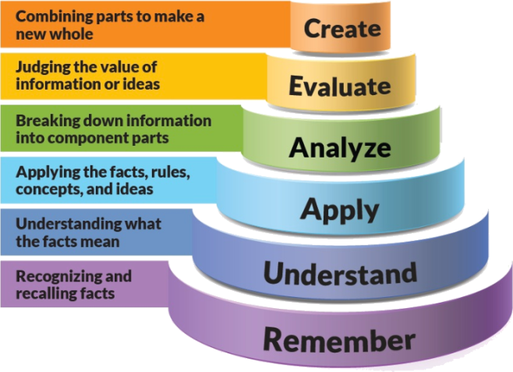
Figure 1: Blooms Taxonomy
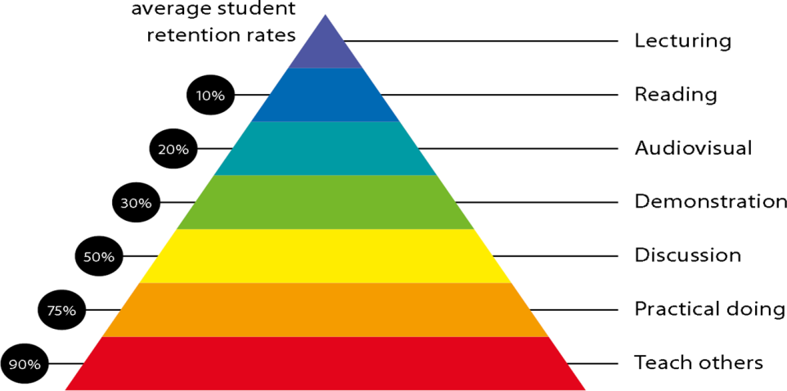
Figure 2: Knowledge retention

Graduate Qualities and Capabilities covered
(Qualities graduates harness crediting this Course)

General Graduate Qualities | Specific Department of ManagementGraduate Capabilities
Informed  Gain an understanding of marketing issues dominating the market in present time which may pose as a threat in marketing but is handled well may lead to better marketer- customer relation. | 1 Market knowledge, & awareness
Independent learners  Locate, evaluate and synthesize complex situations and offer perspectives. Opportunities to acquire these abilities are developed through lectures, and case discussion. | 2 Information literacy, gathering & processing
Problem solvers  Developing critical thinking skills that are pertinent for problem solving and innovation in today’s competitive market. Critically analyze the situation and offer solutions to situations. | 4 Problem solving skills
Effective communicators  Develop the ability to reflect on issues on hand. Through active participation enhance the skills to communicate verbally and in writing and develop practices expected of today’s professionals. | 5 Written communication
 | 6 Oral communication
 | 7 Teamwork
Responsible  Gain a better understanding of sustainable market. Being responsible in dealing and delivering value to all stakeholders | 10 Sustainability, societal & environmental impact

Practical work:
Live project/ Assignments

Lecture/tutorial times:
Lecture Monday 11:45 - 12:40 pm Room LH 35
Lecture Tuesday 9:55 – 10:50 a.m Room LH 35
Lecture Thursday 9:55 – 10:50 p.m. Room LH 35

Attendance Requirements

The University norms states that it is the responsibility of students to attend all lectures, tutorials, seminars and practical work as stipulated in the Course outline. Minimum attendance requirement as per university norms is compulsory for being eligible for mid and end semester examinations.

Details of referencing system to be used in written work

Text books
- Principles of Marketing by Philip Kotler, Gary Armstrong and Prafulla Agnihotri, Pearson

Reference Books:
1. Marketing Management : Indian context by Ramaswami & Namakumari Macmillan (India) Limited ,New Delhi
2. Marketing Strategies by RajanSaxena Tata- McGraw Hill, Publishing Company
3. Marketing management by Tapan panda

Additional Materials
- Newspaper articles
- Video cases on current business issues

ASSESSMENT GUIDELINES
Your final course mark will be calculated from the following:
Assignment 1 5%
Assignment 2 5%
Presentation 5%
Attendance 5 %
Mid semester 40%
Final exam (closed book) 40%

SUPPLEMENTARY ASSESSMENT
Students who receive an overall mark less than 40% in mid semester or end semester will be considered for supplementary assessment in the respective components (i.e mid semester or end semester) of semester concerned. Students must make themselves available during the supplementary examination period to take up the respective components (mid semester or end semester) and need to obtain the required minimum 60% marks to clear the concerned components.

Practical Work Report/Laboratory Report:
A report on the practical work is due the subsequent week after completion of the class by each group.

Late Work
Late assignments will not be accepted without supporting documentation. Late submission of the reports will result in a deduction of 5% of the maximum mark per calendar day

Format
All assignments must be presented in a neat, legible format with all information sources correctly referenced. Assignment material handed in throughout the session that is not neat and legible will not be marked and will be returned to the student.

Retention of Written Work
Written assessment work will be retained by the Course coordinator/lecturer for two weeks after marking to be collected by the students.

University and Faculty Policies
Students should make themselves aware of the University and/or Faculty Policies regarding plagiarism, special consideration, supplementary examinations and other educational issues and student matters.

Plagiarism - Plagiarism is not acceptable and may result in the imposition of severe penalties. Plagiarism is the use of another person’s work, or idea, as if it is his or her own - if you have any doubts at all on what constitutes plagiarism, please consult your Course coordinator or lecturer. Plagiarism will be penalized severely.

Do not copy the work of other students.
Do not share your work with other students (except where required for a group activity or assessment)
.

Course schedule(subject to change)

 | Week # | Topic & contents | CO Addressed | Teaching Learning Activity (TLA)
 | Weeks 1 | Understanding Marketing management nature and scope of marketing management; | CO1 &CO2 | Lecture, Video, & Case Discussion
 | Weeks 2 | Creating Customer value and Engagement, Analyzing the Marketing Environment, | CO1 & CO2 | Lecture, Video, & Case Discussion
 | Week 3 | Understanding changing marketing landscape, Marketing strategy | CO1, CO2 , CO3 | Lecture, Video, & Case Discussion
 | Week 4 | Developing Insights about Marketing Problems and Consumer Behavior:-Identifying and solving marketing problems | CO1, CO2 | Lecture, Video, & Case Discussion
 | Week 5 | Qualitative and quantitative research, Marketing research system & process. Creating customer value and satisfaction; | CO3, CO4 | Lecture, Video, & Case Discussion
 | Week 6 | Factors influencing consumer behavior and buying process. Organizational buying | CO3, CO4 | Lecture, Video, & Case Discussion
 | Week 7 | Identifying Market Segments, Dealing with Competition and Segmentation | CO4, CO5 | Exercise
 | Week 8 | Targeting and positioning. Branding and brand equity | CO5 | Lecture, Video, & Case Discussion
 | Week 9 | Product Strategies, Product classification | CO5 | Lecture, Video, & Case Discussion
 | Week 10 | Product differentiation, Strategies at different stages of product life cycle | CO6 | Lecture, Video, & Case Discussion
 | Week 11 | Service quality and Pricing New product development. Developing Pricing Strategies and Programs | NA | NA
 | Week 12 | Mid sem | CO6 | Lecture, Video, & Case Discussion
 | Week 13 | Distribution - Multichannel marketing, Direct marketing and E-commerce | CO6 | Lecture, Video, & Case Discussion
 | Week 14 | Introduction to Retailing, Wholesaling and Logistics | CO6 | Lecture, Video, & Case Discussion
 | Week 15 | Designing and Managing Integrated Marketing Communications; Mass Communication: Advertising, Sales promotions, Event and experience marketing, and Public Relations. Managing Personal Communications: Direct and Interactive Marketing, word of Mouth and Personal Selling | CO6 | Lecture, Video, & Case Discussion

