Name of Institute: Institute of Management Studies (IMS)

Name of Faculty: Dr Daisy Kurien

Course code: MB0415
Course name: Contemporary Issues in Marketing
Pre-requisites: Marketing Specialisation
Credit points: 3 Credits
Offered Semester: IV

Course Lecturer (Weeks 01 – 15)
Full Name: Dr Daisy Kurien
Department with siting location: Management
Telephone:9428412928
Email: daisykurien.mba@indusuni.ac.in
Consultation times:2:00 pm to 4:00 pm

Students will be contacted throughout the Session via Mail with important information relating to this Course.

Course Objectives
By participating in and understanding all facets of this Course a student will:
- Develop an understanding of various contemporary issues in marketing field
- Recognize business situations which are critical for marketers
- Understand role of marketers in businesses equipping the students to become competent to handle contemporary issues
- Identify and understand possible strategies to handle contemporary issues
- Apply principles and techniques in marketing which will help resolve the issues and result in delivering value to customers

Course Outcomes (CO)

At the completion of the course, the student will be able to:
CO1 Demonstrate meaningful understanding of contemporary issues in marketing.
CO2 Apply marketing concepts and skills across various types of situation in diverse organizations.
CO3 Familiarize with marketing strategies used by established business players
CO4 Describe and understand the importance of contemporary issues and ways to deftly handle them.
CO5 Analyze complex situations prevalent in marketing arena
CO6: To make students aware of the current marketing practices

Course Outline
Module 1 – Contemporary Issues in marketing (CIM) – An Introduction, Pivot Strategy, Changing role of E-commerce- Dominos Quick Service Restaurants – Contactless Delivery, Growth of India’s Ecommerce sector, Green revolution- Sahayadri Farmer Producers, Privacy concerns of websites -Duck Duck Go, Role of Research and development -Bose: Better Products through Research

Module 2 – Contemporary issues – Sustainability by brands- Adidas: Athletic Apparel with purpose, Sensible consumption - Patagonia’s ‘Consious Consumption’: Telling customers to buy less, Online education - Byju’s , Online and offline channels - The Crossword Bookstore story
Module 3 - Contemporary issues : Consumer research - Gillette –Marketing Insights, Cutomer Business Development(CBD) –Procter and Gamble, Bottom of pyramid- TABP Snacks and Beverages
Module 4 – Contemporary issues – Direct and Digital Marketing - Amazon & General Electric, Customer service - Zomato
Module 5 – Contemporary issues - Environmental sustainability, Green marketing , Sustainable Global presence - L’Oreal: The united nations of Beauty, Strategies by Uber radically reshaping urban transportation channel

Method of delivery
Lectures, Role plays, Case studies, Video Cases

Study time
Three hours per week

CO-PO Mapping (PO: Program Outcomes)

 | PO 1 | PO 2 | PO 3 | PO 4 | PO 5 | PO 6
CO 1 | 3 | 2 | 3 | 2 | 1 | 1
CO 2 | 3 | 3 | 1 | 3 | 3 | 1
CO 3 | 3 | 3 | 1 | 2 | 3 | 3
CO 4 | 1 | 3 | 3 | 1 | 3 | 3
CO 5 | 2 | 2 | 3 | 2 | 1 | 1
CO6 | 3 | 1 | 1 | 1 | 1 | 1

Blooms Taxonomyand Knowledge retention(For reference)
(Blooms taxonomy has been given for reference)

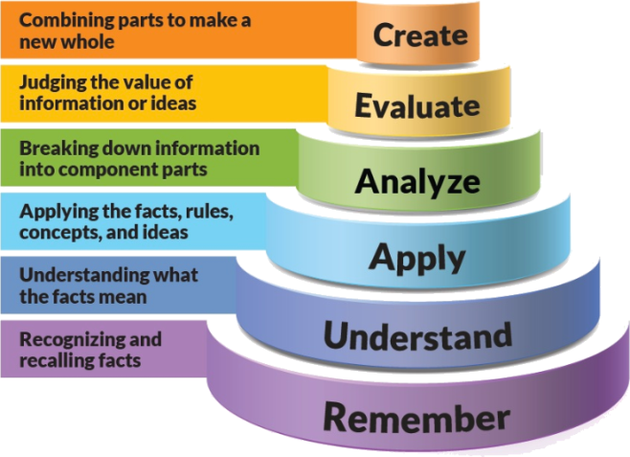
Figure 1: Blooms Taxonomy
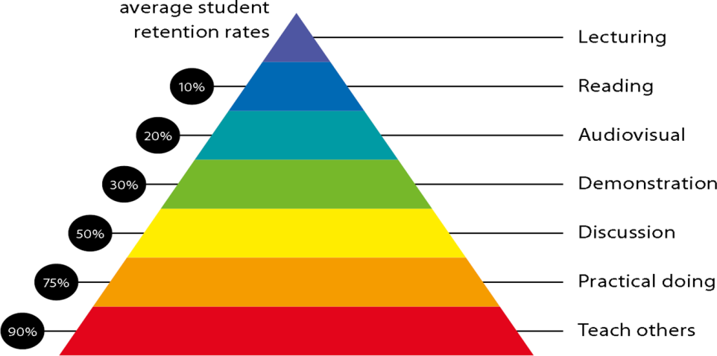
Figure 2: Knowledge retention

Graduate Qualities and Capabilities covered
(Qualities graduates harness crediting this Course)

General Graduate Qualities | Specific Department of ManagementGraduate Capabilities
Informed  Gain an understanding of marketing issues dominating the market in present time which may pose as a threat in marketing but is handled well may lead to better marketer- customer relation. | 1 Market knowledge, & awareness
Independent learners  Locate, evaluate and synthesize complex situations and offer perspectives. Opportunities to acquire these abilities are developed through lectures, and case discussion. | 2 Information literacy, gathering & processing
Problem solvers  Developing critical thinking skills that are pertinent for problem solving and innovation in today’s competitive market. Critically analyze the situation and offer solutions to situations. | 4 Problem solving skills
Effective communicators  Develop the ability to reflect on issues on hand. Through active participation enhance the skills to communicate verbally and in writing and develop practices expected of today’s professionals. | 5 Written communication
 | 6 Oral communication
 | 7 Teamwork
Responsible  Gain a better understanding of sustainable market. Being responsible in dealing and delivering value to all stakeholders | 10 Sustainability, societal & environmental impact

Practical work:
Live project/ Assignments

Lecture/tutorial times:
Lecture Monday 02:15- 3:10 pm Room LH 35
Lecture Thursday 09:00 – 9:55 am Room LH 35
Lecture Friday 09:00 – 9:55 am Room LH 35

Attendance Requirements

The University norms states that it is the responsibility of students to attend all lectures, tutorials, seminars and practical work as stipulated in the Course outline. Minimum attendance requirement as per university norms is compulsory for being eligible for mid and end semester examinations.

Details of referencing system to be used in written work

Text books
1. Contemporary Issues in Marketing by Dr. Rakesh Kumar, Global Vision Publishing House, 1st Edition

Additional Materials
- Newspaper articles
- Video cases on current business issues

ASSESSMENT GUIDELINES
Your final course mark will be calculated from the following:
Assignment 1 5%
Assignment 2 5%
Presentation 5%
Attendance 5 %
Mid semester 40%
Final exam (closed book) 40%

SUPPLEMENTARY ASSESSMENT
Students who receive an overall mark less than 40% in mid semester or end semester will be considered for supplementary assessment in the respective components (i.e mid semester or end semester) of semester concerned. Students must make themselves available during the supplementary examination period to take up the respective components (mid semester or end semester) and need to obtain the required minimum 60% marks to clear the concerned components.

Practical Work Report/Laboratory Report:
A report on the practical work is due the subsequent week after completion of the class by each group.

Late Work
Late assignments will not be accepted without supporting documentation. Late submission of the reports will result in a deduction of 5% of the maximum mark per calendar day

Format
All assignments must be presented in a neat, legible format with all information sources correctly referenced. Assignment material handed in throughout the session that is not neat and legible will not be marked and will be returned to the student.

Retention of Written Work
Written assessment work will be retained by the Course coordinator/lecturer for two weeks after marking to be collected by the students.

University and Faculty Policies
Students should make themselves aware of the University and/or Faculty Policies regarding plagiarism, special consideration, supplementary examinations and other educational issues and student matters.

Plagiarism - Plagiarism is not acceptable and may result in the imposition of severe penalties. Plagiarism is the use of another person’s work, or idea, as if it is his or her own - if you have any doubts at all on what constitutes plagiarism, please consult your Course coordinator or lecturer. Plagiarism will be penalized severely.

Do not copy the work of other students.
Do not share your work with other students (except where required for a group activity or assessment)
.

Courseschedule(subject to change)

 | Week # | Topic & contents | CO Addressed | Teaching Learning Activity (TLA)
 | Weeks 1 | Contemporary Issues in marketing (CIM) – An Introduction, Pivot Strategy | CO1 ,CO2 | Lecture, Video, & Case Discussion
 | Weeks 2 | Changing role of E-commerce- Dominos Quick Service Restaurants – Contactless Delivery | CO3 | Lecture, Video, & Case Discussion
 | Week 3 | Growth of India’s Ecommerce sector, Green revolution- Sahayadri Farmer Producers | CO3 | Lecture, Video, & Case Discussion
 | Week 4 | Privacy concerns of websites -Duck Duck Go, Role of Research and development -Bose: Better Products through Research | CO4 | Lecture, Video, & Case Discussion
 | Week 5 | Contemporary issues – Sustainability by brands- Adidas: Athletic Apparel with purpose | CO4 | Lecture, Video, & Case Discussion
 | Week 6 | Sensible consumption - Patagonia’s ‘Consious Consumption’: Telling customers to buy less | CO6 | Lecture, Video, & Case Discussion
 | Week 7 | Online education - Byju’s , Online and offline channels - The Crossword Bookstore story | CO5 | Lecture, Video, & Case Discussion
 | Week 8 | Contemporary issues : Consumer research - Gillette –Marketing Insights, | CO5 | Lecture, Video, & Case Discussion
 | Week 9 | Cutomer Business Development(CBD) –Procter and Gamble, | CO6 | Lecture, Video, & Case Discussion
 | Week 10 | Bottom of pyramid- TABP Snacks and Beverages | CO5, CO6 | Lecture, Video, & Case Discussion
 | Week 11 | Mid sem exam | NA | NA
 | Week 12 | Direct and Digital Marketing - Amazon & General Electric, | CO1, CO2 | Lecture, Video, & Case Discussion
 | Week 13 | Customer service - Zomato | CO3 | Lecture, Video, & Case Discussion
 | Week 14 | Environmental sustainability, Green marketing , Sustainable Global presence - L’Oreal: The united nations of Beauty, | CO6 | Lecture, Video, & Case Discussion
 | Week 15 | Strategies by Uber radically reshaping urban transportation channel | CO2 | Lecture, Video, & Case Discussion

