Name of Institute: Institute of Management Studies (IMS) Name of Faculty: Dr Daisy Kurien

Course code: IMBO612

Course name: Consumer Behavior
Pre-requisites: Marketing Specialisation Credit points: 3 Credits
Offered Semester: III

Course Lecturer(1 to 15 weeks)
Full Name: Dr Daisy Kurien
Department with siting location: Management Telephone:9428412928
Email: daisykurien.mba@indusuni.ac.in Consultation times:2:00 pm to 4:00 pm

Students will be contacted throughout the Session via Mail with important information relating to this Course.

Course Objectives
By participating in and understanding all facets of this Course a student will:
- Familiarize the students with the behavioural aspects of consumers.
- To understand the internal forces, external influences and processes that goes on to affect consumer behaviour, the challenges generated for the marketers and the strategies which could be implemented

Course Outcomes (CO)

At the completion of the course, the student will be able to:

CO1. Examine the nature of Consumer behaviour and know how knowledge of consumer behaviour can be applied to marketing.
CO2. Comprehend the major concepts of Consumer Behavior and list their applications in marketing of products and services.
CO3: Identify build an understanding of the wide range of social, cultural and economic factors which influence consumer behaviour.
CO4: Analyze the decision making process of the consumers
CO5: Make a sense of select models used for understanding Consumer Behavior
CO6: Integrate dynamics of personality, perception, learning motivation and attitude to the choices consumers make.

Course Outline
Module 1 – Understanding the Consumer: Consumer Behavior: Meeting Changes and Challenges, The Consumer Research Process, Market Segmentation and Strategic Targeting

Module 2 – The Consumer as an Individual: Consumer Motivation, Personality and Consumer Behavior, Consumer Perception

Module 3 - The Consumer as an Individual: Consumer Learning, Consumer Attitude Formation and Change, Communication and Consumer Behavior

Module 4 – Consumers in their Social and Cultural Settings :The Family and Social Class, Influence of Culture on Consumer Behavior, Cross-Cultural Consumer Behavior: An International Perspective

Module 5 – The Consumer’s Decision-Making Process and Ethical Dimensions: Consumers and the Diffusion of Innovations, Consumer Decision Making and Beyond, Marketing Ethics and Social Responsibility

Method of delivery
Lectures, Case studies, Video Cases

Study time
Three hours per week

 | PO 1 | PO 2 | PO 3 | PO 4 | PO 5 | PO 6
CO 1 | 3 | 1 | 3 | 3 | 3 | 2
CO 2 | 3 | 1 | 3 | 3 | 1 | 2
CO 3 | 3 | 3 | 3 | 3 | 3 | 3
CO 4 | 3 | 2 | 3 | 2 | 3 | 2
CO 5 | 3 | 1 | 1 | 1 | 3 | 1
CO 6 | 3 | 3 | 3 | 2 | 2 | 3

CO-PO Mapping (PO: Program Outcomes)

Blooms Taxonomyand Knowledge retention(For reference)
(Blooms taxonomy has been given for reference)
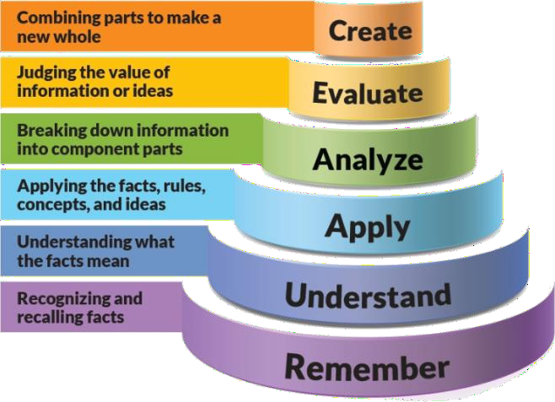
Figure 1: Blooms Taxonomy

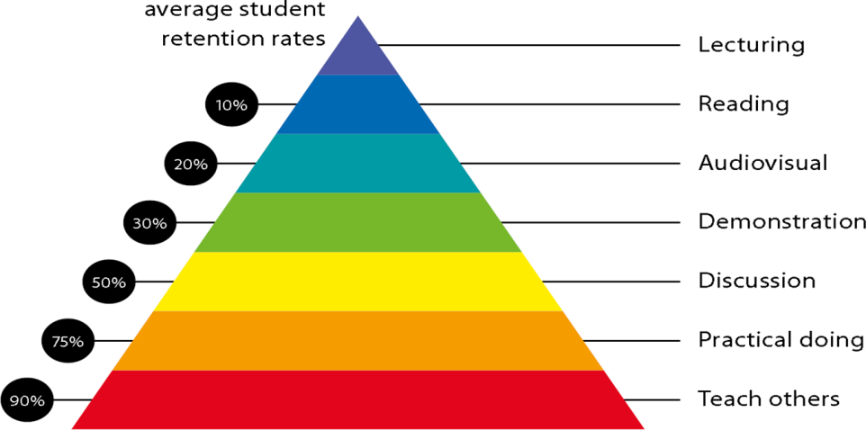
Figure 2: Knowledge retention

Graduate Qualities and Capabilities covered
(Qualities graduates harness crediting this Course)

General Graduate Qualities | Specific Department of ManagementGraduate Capabilities
Informed  Gain an understanding of marketing issues dominating the market in present time which may pose as a threat in  marketing but is handled well may lead to better marketer- customer relation. | 1 Market knowledge, & awareness
Independent learners | 2 Information literacy, gathering &
Locate, evaluate and synthesize complex | processing
situations and offer perspectives.
Opportunities to acquire these abilities
are developed through lectures, and
case discussion.
Problem solvers  Developing critical thinking skills that are pertinent for problem solving and innovation in today’s competitive market. Critically analyze the situation and offer  solutions to situations. | 4 Problem solving skills
Effective communicators | 5 Written communication
Develop the ability to reflect on issues on | 6 Oral communication
hand. Through active participation  enhance the skills to communicate | 7 Teamwork
verbally and in writing and develop
practices expected of today’s
professionals.
Responsible | 10 Sustainability, societal &
Gain a better understanding of | environmental impact
sustainable market. Being
responsible in dealing and delivering
value to all stakeholders

Practical work:
Live project/ Assignments

Lecture/tutorial times:

Lecture | Tuesday | 2:15 to 03:10 pm | Room LH 36
Lecture | Wednesday | 03:10 to 04:05 pm | Room LH 36
Lecture | Friday | 10:50 to 11:45 pm | Room LH 36

Attendance Requirements

The University norms states that it is the responsibility of students to attend all lectures, tutorials, seminars and practical work as stipulated in the Course outline. Minimum attendance requirement as per university norms is compulsory for being eligible for mid and end semester examinations.

Details of referencing system to be used in written work

Text books
1. Leslie Lazar Kanuk,S. Ramesh Kumar,Leon G. Schiffman, Consumer Behaviour, Pearson

Reference Books:
- Blackwell and Engel,Consumer Behaviour, Cenage.
- MajumudarRamanuj,Consumer Behaviour , Insights from Indian Market, PHI
- Hoyer, Maclnnis andDasguptaBiztantra, Consumer Behaviour
- Evans, Consumer Behaviour,Wiley
- Lingquist Jay D, Consumer Behaviour, Cengage
- David Loudon, Albert Della Bitta, Consumer Bahavior.Tata McGraw Hill.

Additional Materials
  - Newspaper articles
  - Video cases on current business issues

ASSESSMENT GUIDELINES
Your final course mark will be calculated from the following:
bject-Contemporary Issues in Marketing (CIM) Semester: IV (Year 2) Page 5 of 8

Assignment 1
Assignment 2 Presentation Attendance
Su Mid semester
Final exam (closed book)
5%
5%
5%
5 %
40%
40%

SUPPLEMENTARY ASSESSMENT
Students who receive an overall mark less than 40% in mid semester or end semester will be considered for supplementary assessment in the respective components (i.e mid semester or end semester) of semester concerned. Students must make themselves available during the supplementary examination period to take up the respective components (mid semester or end semester) and need to obtain the required minimum 60% marks to clear the concerned components.

Practical Work Report/Laboratory Report:
A report on the practical work is due the subsequent week after completion of the class by each group.

Late Work
Late assignments will not be accepted without supporting documentation. Late submission of the reports will result in a deduction of 5% of the maximum mark per calendar day

Format
All assignments must be presented in a neat, legible format with all information sources correctly referenced. Assignment material handed in throughout the session that is not neat and legible will not be marked and will be returned to the student.

Retention of Written Work
Written assessment work will be retained by the Course coordinator/lecturer for two weeks after marking to be collected by the students.

University and Faculty Policies
Students should make themselves aware of the University and/or Faculty Policies regarding plagiarism, special consideration, supplementary examinations and other educational issues and student matters.

Plagiarism - Plagiarism is not acceptable and may result in the imposition of severe penalties. Plagiarism is the use of another person’s work, or idea, as if it is his or her own
- if you have any doubts at all on what constitutes plagiarism, please consult your Course coordinator or lecturer. Plagiarism will be penalized severely.

Do not copy the work of other students.
Do not share your work with other students (except where required for a group activity or assessment)

.

Courseschedule(subject to change)

 | Week # | Topic & contents | CO  Addressed | Teaching Learning Activity (TLA)
 | Weeks 1 | Consumer Behavior: Meeting Changes and Challenges | CO1 &CO2 | Lecture, Video, & Case Discussion
 | Weeks 2 | The Consumer Research Process | CO1 & CO2 | Lecture, Video, & Case Discussion
 | Week 3 | The Consumer Research Process | CO1, CO2 & CO3 | Lecture, Video, & Case Discussion
 | Week 4 | Market Segmentation Strategic Targeting | CO1, CO2 & CO6 | Lecture, Video, & Case Discussion
 | Week 5 | Consumer Motivation | CO6 | Lecture, Video, & Case Discussion
 | Week 6 | Personality and Consumer Behavior, | CO6 | Lecture, Video, & Case Discussion
 | Week 7 | Consumer Learning, Consumer Attitude Formation and change | CO6 | Lecture, Video, & Case Discussion
 | Week 8 | Communication and Consumer Behavior | CO6 | Lecture, Video, & Case Discussion
 | Week 9 | The Family and Social Class, Influence of Culture on Consumer Behavior, | CO3, CO6 | Lecture, Video, & Case Discussion
 | Week 10 | Cross-Cultural Consumer Behavior: An International Perspective | CO3 | Lecture, Video, & Case Discussion
 | Week 11 | Mid Sem exam
 | Week 12 | Consumers and the Diffusion of Innovations, Consumer Decision Making and Beyond, | CO3 | Lecture, Video, & Case Discussion
 | Week 13 | Marketing Ethics and Social Responsibility | CO4 | Lecture, Video, & Case Discussion

 | Week 14 | Consumer Decision Making and the Diffusion of Innovations | CO4, CO5 | Lecture, Video, & Case Discussion
 | Week 15 | Marketing Ethics and Social Responsibility, Consumer Research | CO4 | Lecture, Video, & Case Discussion

