Name of Institute: INDUS INSTITUTE OF MANAGEMENT
Name of Faculty: Dr. PARSHVA SHAH

Course code: BC0515
Course name: Computerized Accounting System
Pre-requisites:
Credit points: 6
Offered Semester: V

Course Coordinator (weeks 15)
Full Name: Prof. Parshva Jitendrakumar Shah
Department with siting location: MBA Department, Bhawar Buliding 4th Floor
Telephone: 9737530515
Email: parshvashah.mba@indusuni.ac.in
Consultation times: 2.00 PM to 4.00 PM

Course Lecturer (weeks 15)
Full Name: Prof. Parshva Jitendrakumar Shah
Department with siting location: MBA Department, Bhawar Buliding 4th Floor
Telephone: 9737530515
Email: parshvashah.mba@indusuni.ac.in
Consultation times: 2.00 PM to 4.00 PM

Students will be contacted throughout the Session via Mail with important information relating to this Course.

Course Objectives

This course seeks to enhance the skills needed for computerized accounting system and to enable the students to develop simple accounting applications.

Course Outcomes (CO)

CO1-To familiar with study of advanced Excel functions with an emphasis on accounting
themes.
CO2- Introduced to computerized accounting systems using the Tally Accounting software.
CO3- To familiar with praparation of Final Accounts in tally software
CO4- To know diffrent accounting entries and journals made for adjustment of transaction
in tally software
CO5- To know the impact of tax laws on companies and individuals
CO6- Records of different vouchers , receipts and payment entries in tally erp software

Course Outline

Module-I

Basic Accounting
• Introduction & Advantage of Tally Company information
• Select company, Shut company, Create company, Alter, Backup, Restore

Module-II

Gateway of Tally Account info
• Group, Ledgers, Voucher types
Inventory info
• Stock group, Stock item, Units of Measurement

Module-III

Accounting Vouchers
• Contra, Payment, Receipt, Sale, Purchase and Journal.

Module-IV

GOODS AND SERVICE TAX (GST)
• Create Company and Activate GST in Company Level
• Creating Master and Set GST Rates
• Creating Tax Ledgers
• Transferring Tax Credits of VAT,
• Excise and Service Tax to GST
• Recording GST Sales and Printing Invoices
• Recording GST Interstate Sales and Printing Invoices
• Recording an Advance to Supplier under GST
• Recording GST Local Purchase
• Recording GST Interstate

Method of delivery
Face to face lectures, self study material, Active Learning Techniques, Chalk & Board, Power Point Presentation(PPT), Group Discussion, Major Projects, Tally ERP 9 etc.

Study time
6 lecture per week, Average attendance 80%

CO-PO Mapping (PO: Program Outcomes)
 | Introduction to Taxation | PO1 | PO2 | PO3 | PO4 | PO5 | PO6
CO1 | To familiar with study of advanced Excel functions with an emphasis on accounting themes. | 2 | 3 | 2 | 3 | 3 | 1
CO2 | Introduced to computerized accounting systems using the Tally Accounting software. | 2 | 2 | 2 | 2 | 3 | 3
CO3 | To familiar with preparation of Final Accounts in tally software | 2 | 3 | 3 | 2 | 2 | 1
CO4 | To know different accounting entries and journals made for adjustment of transaction in tally software | 2 | 2 | 2 | 3 | 3 | 3
CO5 | To know the impact of tax laws on companies and individuals | 2 | 2 | 3 | 2 | 3 | 1
CO6 | Records of different vouchers , receipts and payment entries in tally erp software | 3 | 2 | 2 | 2 | 2 | 2

Blooms Taxonomy and Knowledge retention (For reference)
(Blooms taxonomy has been given for reference)

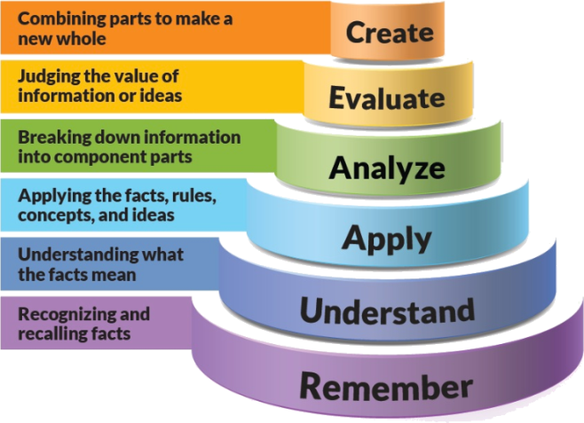
Figure 1: Blooms Taxonomy
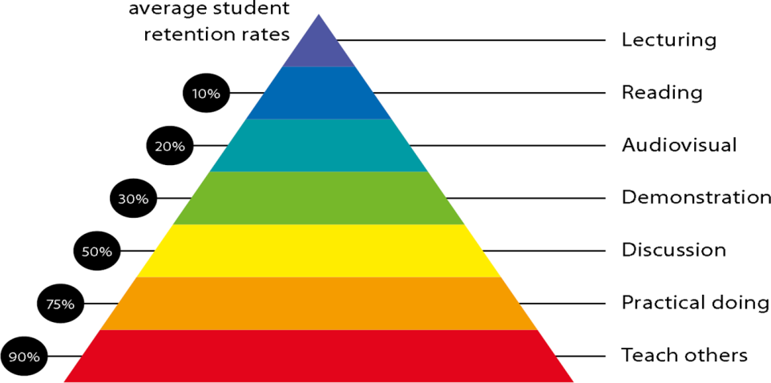
Figure 2: Knowledge retention

Graduate Qualities and Capabilities covered
(Qualities graduates harness crediting this Course)

General Graduate Qualities | Specific Department of ______Graduate Capabilities
Informed  Disciplinary Knowledge  - Excel  - Tally ERP  - Tally ERP 9 | 1 Professional knowledge, grounding & awareness
Independent learners  - Metacognition  - Planning  - Evaluating | 2 Information literacy, gathering & processing
Problem solvers  Thinking • critical • creative • practical | 4 Problem solving skills
Effective communicators  Relating • communication • team skills • influencing • acting ethically • cross-cultural awareness | 5 Written communication
 | 6 Oral communication
 | 7 Teamwork
Responsible  Learning • capacity for life-long learning • flexibility • adaptability | 10 Sustainability, societal & environmental impact

Practical work:
Case Study, Presentation , Practical problems of each .
- ASSIGNMENT -1 Theory aspect question
- ASSIGNMENT -2 Practical questions
- MCQ Test
- Practical Case Discussion
- Projects

Lecture/tutorial times
(Give lecture times in the format below)
Lecture | Monday | 12:20 – 1:20 | PG Classes
Lecture | Tuesday | 12:20 – 1:20 | PG Classes
Lecture | Wednesday | 12:20 – 1:20 | PG Classes
Lecture | Thursday | 11:10 – 12:10  12:20 – 1:20 | PG Classes | Wednesday | 11:55- 12:50 | PG Classes
Lecture | Friday | 12:20 – 1:20 | PG Classes | Thursday | 11:55- 12:50 | Lecture

Attendance Requirements

The University norms states that it is the responsibility of students to attend all lectures, tutorials, seminars and practical work as stipulated in the Course outline. Minimum attendance requirement as per university norms is compulsory for being eligible for mid and end semester examinations.

Details of referencing system to be used in written work

Text books

- Tally ERP 9 Training Guide by Ashok K Nodhani, BPB Publisher
- Tally ERP 9 GST A Complete Test Book with Assignment in English by T Balaji

Additional Materials
Names of newspapers, magazines to be referred for better understanding of the course:
- Times of India, Economics Times, Business Standard ,
- Taxman. Taxman Allied Services Pvt. Ltd., New Delhi.

ASSESSMENT GUIDELINES
Your final course mark will be calculated from the following:
- ASSIGNMENT -1 Theory aspect question 05 Marks
- ASSIGNMENT -2 Practical questions 10 Marks
- Mid Semester 40 Marks
- Class Performance / Attendance 05 Marks
- End Semester 40 Marks

SUPPLEMENTARY ASSESSMENT

Students who receive an overall mark less than 40% in mid semester or end semester will be considered for supplementary assessment in the respective components (i.e mid semester or end semester) of semester concerned. Students must make themselves available during the supplementary examination period to take up the respective components (mid semester or end semester) and need to obtain the required minimum 40% marks to clear the concerned components.

Late Work
Late assignments will not be accepted without supporting documentation. Late submission of the reports will result in a deduction of -% of the maximum mark per calendar day

Format
All assignments must be presented in a neat, legible format with all information sources correctly referenced. Assignment material handed in throughout the session that is not neat and legible will not be marked and will be returned to the student.

Retention of Written Work
Written assessment work will be retained by the Course coordinator/lecturer for two weeks after marking to be collected by the students.

University and Faculty Policies
Students should make themselves aware of the University and/or Faculty Policies regarding plagiarism, special consideration, supplementary examinations and other educational issues and student matters.

Plagiarism - Plagiarism is not acceptable and may result in the imposition of severe penalties. Plagiarism is the use of another person’s work, or idea, as if it is his or her own - if you have any doubts at all on what constitutes plagiarism, please consult your Course coordinator or lecturer. Plagiarism will be penalized severely.

Do not copy the work of other students.
Do not share your work with other students (except where required for a group activity or assessment)
.

Course schedule (subject to change)
(Mention quiz, assignment submission, breaks etc as well in the table under the Teaching Learning Activity Column)

 | Week # | Topic & contents |  |  | CO Addressed | Teaching Learning Activity (TLA)
 | Weeks 1 | Introduction & Advantages of Tally |  |  | CO1,CO2,CO4 | Chalk & Board / / PPT / Handouts / Tutorials / Assignments,
 | Weeks 2 | Company information  • Select company, Shut company, Create company, Alter, Backup, Restore |  |  | CO1,CO2,CO4,CO6 | Chalk & Board / / PPT / Handouts / Tutorials / Assignments,
 | Week 3 | Company information  • Select company, Shut company, Create company, Alter, Backup, Restore |  |  | CO1,CO2,,CO4,CO6 | Chalk & Board / / PPT / Handouts / Tutorials / Assignments,
 | Week 4 | Gateway of Tally Account info  • Group, Ledgers, Voucher types |  |  | CO1,CO2,CO4,CO5,CO6 | Chalk & Board / / PPT / Handouts / Tutorials / Assignments,
 | Week 5 | Inventory info  • Stock group, Stock item, Units of Measurement |  |  | CO1,CO2,CO4,CO5,CO6 | Chalk & Board / / PPT / Handouts / Tutorials / Assignments,
 | Week 6 | Inventory info  • Stock group, Stock item, Units of Measurement |  | CO2,CO4,CO5,CO6 |  | Chalk & Board / / PPT / Handouts / Tutorials / Assignments,
 | Week 7 | Accounting Vouchers  • Contra, Payment, Receipt, Sale, Purchase and Journal. |  | CO2,CO4,CO5,CO6 |  | Chalk & Board / / PPT / Handouts / Tutorials / Assignments,
 | Week 8 | Accounting Vouchers  • Contra, Payment, Receipt, Sale, Purchase and Journal. |  | CO2,CO4,CO5,CO6 |  | Chalk & Board / / PPT / Handouts / Tutorials / Assignments,
 | Week 9 | GOODS AND SERVICE TAX (GST)  • Create Company and Activate GST in Company Level  • Creating Master and Set GST Rates  • Creating Tax Ledgers |  | CO2,CO3,CO4,CO5,CO6 |  | Chalk & Board / / PPT / Handouts / Tutorials / Assignments,
 | Week 10 | Transferring Tax Credits of VAT,  • Excise and Service Tax to GST  • Recording GST Sales and Printing Invoices |  | CO2,CO3,CO4,CO5,CO6 |  | Chalk & Board / / PPT / Handouts / Tutorials / Assignments,
 | Week 11 | Mid Term Exam |  | Mid Term Exam |  | Mid Term Exam
 | Week 12 | Recording GST Sales and Printing Invoices |  | CO2,CO3,CO4,CO5,CO6 |  | Chalk & Board / / PPT / Handouts / Tutorials / Assignments,
 | Week 13 | Recording GST Interstate Sales and Printing Invoices  • Recording an Advance to Supplier under GST |  | CO2,CO3,CO4,CO5,CO6 |  | Chalk & Board / / PPT / Handouts / Tutorials / Assignments,
 | Week 14 | Recording GST Local Purchase |  | CO2,CO3,CO4,CO5,CO6 |  | Chalk & Board / / PPT / Handouts / Tutorials / Assignments,
 | Week 15 | Recording GST Interstate |  | CO2,CO3,CO4,CO5,CO6 |  | Chalk & Board / / PPT / Handouts / Tutorials / Assignments,

Assessment Process:

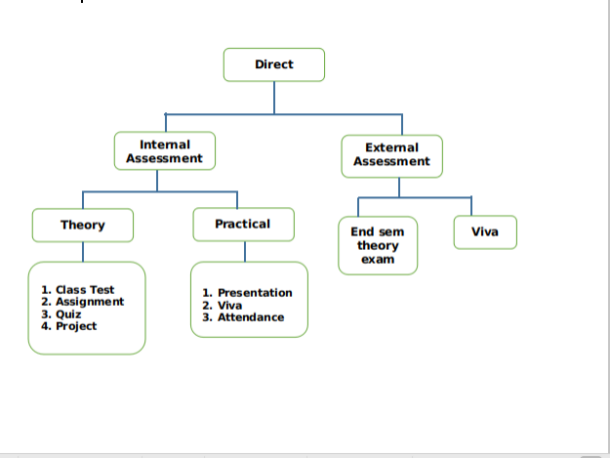
Direct Assessment method – The knowledge and skills learnt by the students are assessed directly from their performance through internal assessment and external assessment processes.
External assessment- Performance of student is recorded in university theory exams, laboratory exams and project evaluation.
Internal assessment- Performance of student is recorded through class assignments and tutorials, internal assessment tests, laboratory assignments, seminars and project progress review and evaluation.
TAttainment of Course Outcomes (CO’s)Test

For End Semester Theory and Practical Exams
- Attainment Level 1: If < 45% students scoring ≥60% marks
- Attainment Level 2: If >45-75% students scoring ≥60% marks
- Attainment Level 3: If >75-100% students scoring ≥60% marks
For Internal Theory and Practical Exams
- Attainment Level 1: If <45% students scoring ≥75% marks
- Attainment Level 2: If >45-75% students scoring ≥75% marks
- Attainment Level 3: If >75-100% students scoring ≥75% marks
Weights of Attainments are assigned as per University Evaluation criteria as below for A.Y. 2019-20
1. For all courses except courses marked with (*)
INDUS University End Sem Examinations : Weightage: 40%
Internal Assessment : Weightage: 60%
2. Courses marked with (*)
INDUS University External Examinations : Weightage: 0%
Internal Assessment : Weightage: 100%

Internal Component with COs mapping
 | Name of the Component | Total marks | CO mapped
Component-1 | Mid Sem | 40 | CO-1, CO-2,CO-3
Component-2 | Assignment-1 | 05 | CO--1, CO-2
Component-3 | Assignment-1I | 10 | CO-5, CO-6
Component-4 | Attendance | 05 | CO--1,CO-2,CO-3, CO-4, CO-5, CO-6

Course Attainment

Academic Year 2019-2020

Course Name with Code | Computerized Accounting System (BC0515)
Class | Semester - V, B.Com
Faculty Name | Mr. Parshva Shah

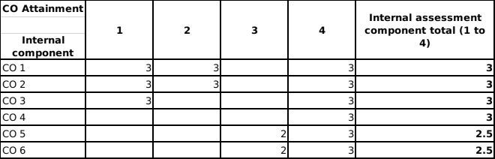

CO Attainment

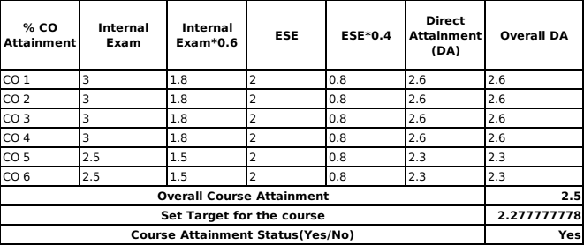

Best Performing CO: | CO1, CO2
Least Performing CO | CO5,CO6

Observations:
1 | Overall attainment level of CO5 and CO6 is less
2 | CO attainment has been attained

Plan of Action:
1 | More focus is need to be provided for CO5 and CO6
2 | More contribution from the faculty is required for CO5 and CO6

